1. The Problem / Situation
When testing the new virtual host using the instance's public IP address, the browser displayed a 404 Not Found error instead of the custom web page. This happened because Apache did not know how to route the raw IP address, and it defaulted to an inactive configuration. Later, when trying to pull the AWS metadata to display on the page, the terminal kept freezing or printing a mess of dates because the AWS Instance Metadata Service (IMDSv2) was set to "Required" by default, and the command was missing the exact subfolder paths.

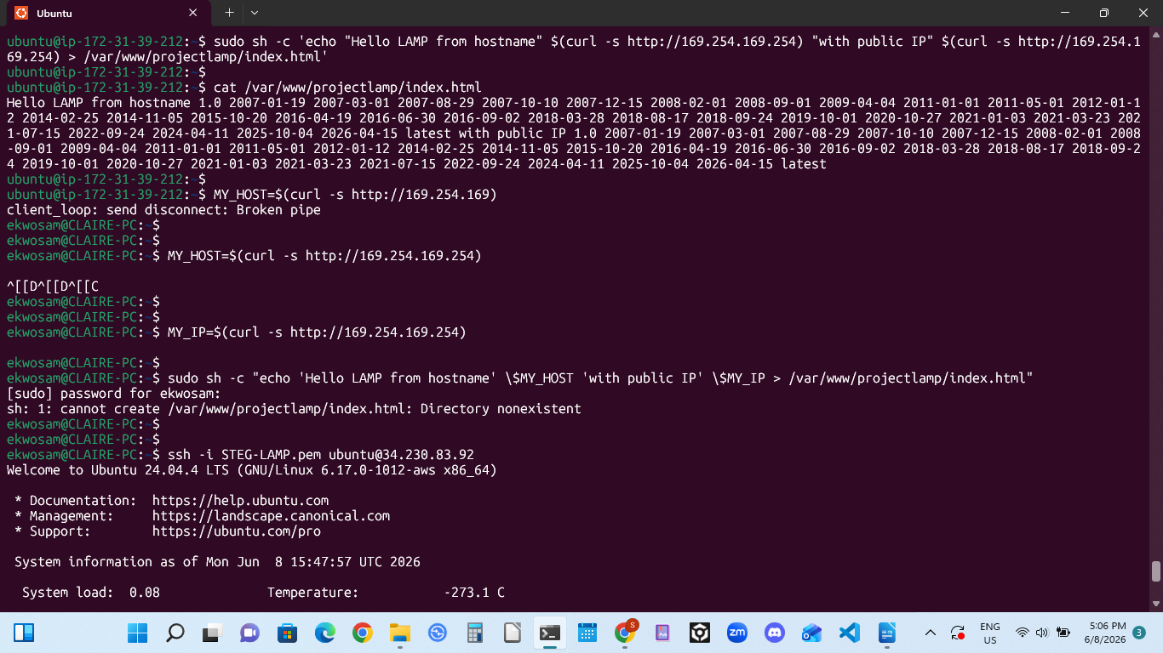
2. The Task Required
The objective was to successfully configure a custom Apache Virtual Host for a local test domain (www.projectlamp). The page needed to dynamically fetch and display the AWS EC2 instance's public hostname and public IPv4 address using curl commands, ensuring it loaded perfectly in a web browser without any errors.
3. Actions Taken to Resolve It
- Mapped the Local Domain: Updated the Windows hosts file to point www.projectlamp directly to the AWS public IP address.
- Optimized Apache: Disabled the default Apache landing profile (000-default) and enabled the custom projectlamp site profile, fixing a syntax typo along the way before reloading Apache.
- Adjusted AWS Security Settings: Modified the EC2 instance metadata settings in the AWS Console, switching IMDSv2 from Required to Optional to allow standard metadata queries.
- Executed the Correct Command: Ran the final string using sudo sh -c alongside the explicit /latest/meta-data/public-hostname and /latest/meta-data/public-ipv4 paths. This successfully generated the clean index.html file showing the actual AWS server details.

